- \Operation\TZ-tube transport conveyor\Tube transport conveyor
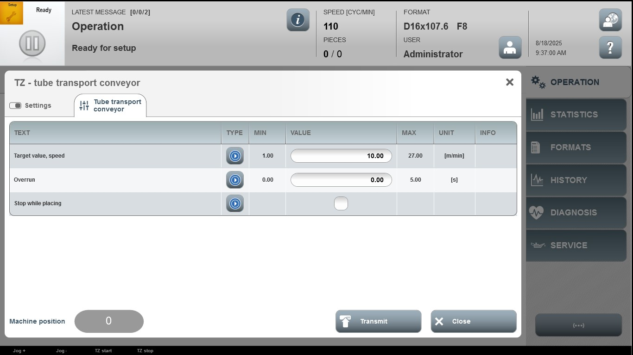

Acceptance criterion | Limits | Pass / Fail: Dev-No. | Date | Initials
Screen matches screenshot | N / A
Target value, speed | 1.00…27.00
Overrun | 0.00…5.00

